Fairhaven Ministry of Faith, Hope, & Love

Administrator: Mrs. Harold Brown 21066 Fairhaven Rd.
Directors: Mr. & Mrs. Johnny Huffman P. O. Box 1207
Phone: 985-892-1134 Covington, La. 70434
Fax: 985-892-1385 Web: hopeforothers.org
E-Mail: Johnny@fairhavenministry.com
Phillipians 6:13,14--Brethren, I count not myself to have apprehended: but this one thing I do, forgetting those things which are behind, and reaching forth unto those things which are before,¹⁴ I press toward the mark for the prize of the high calling of God in Christ Jesus.
Dear Friends,

I pray that the new year finds all of you well and looking forward to serving the Lord in this coming year.

As you can see from the pictures, our children had a great Christmas because of so many of you. We thank you for your desire to share your Christmas with us.

It is my prayer that as we go forth into this new year, we will do it with the purpose of serving the Lord and serving others more than ever before. I also pray that we will see His direction in the decisions we make and that we will seek His direction for our lives, our families, and our country.

It was 52 years ago this month that the Lord spoke to Bro. Harold Brown and his wife Jackie and told them that it was time to start a children’s home. If you would like to read her book, you can find it on our web page now, entitled “The Path That We Have Trod”. Many have told me what a blessing the book has been to them. We praise God for His faithfulness through the years. It is, and always will be, our desire that whatever good is accomplished through Fairhaven will only glorify Him.

As always, thank you all for your continued prayers and support. May He bless you all “beyond measure”.

In His Service,
Johnny, Sissie, Jackie, and Kids

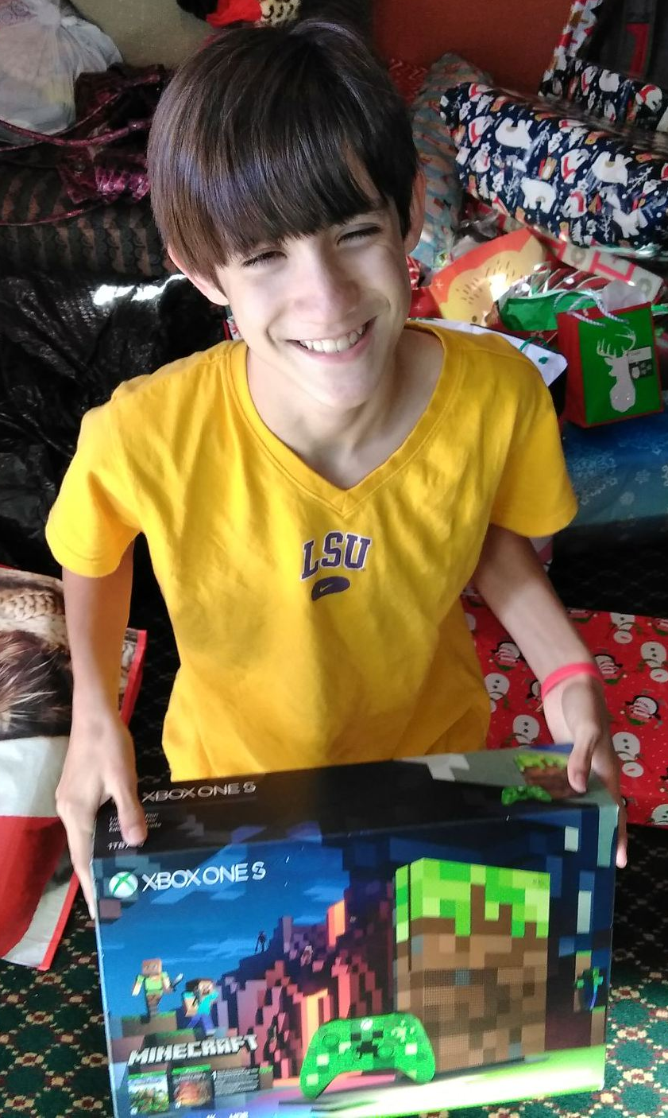
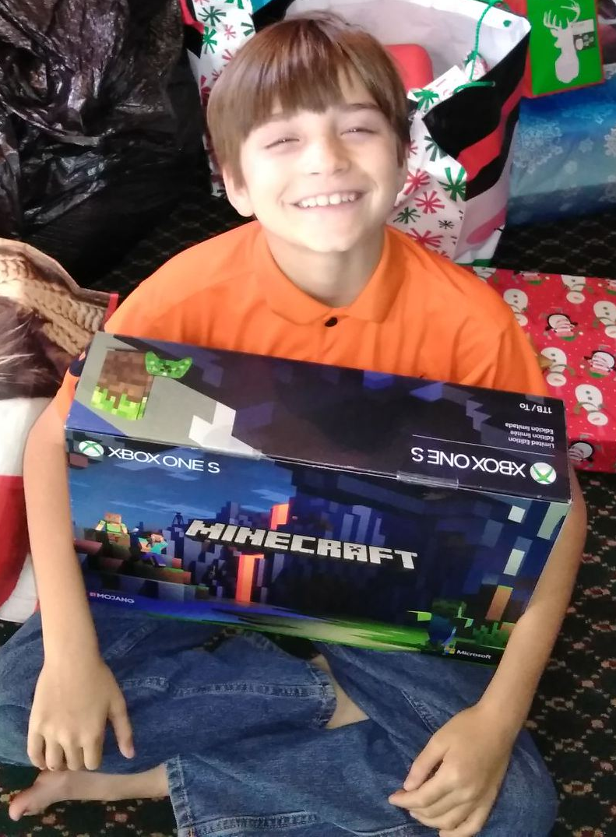
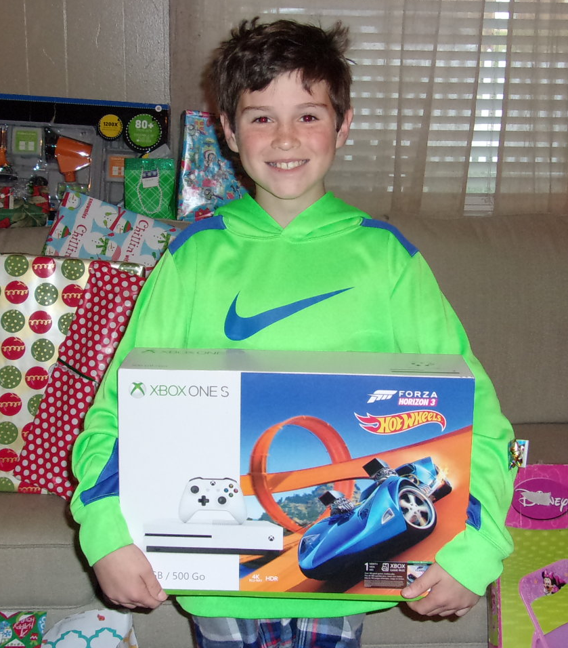
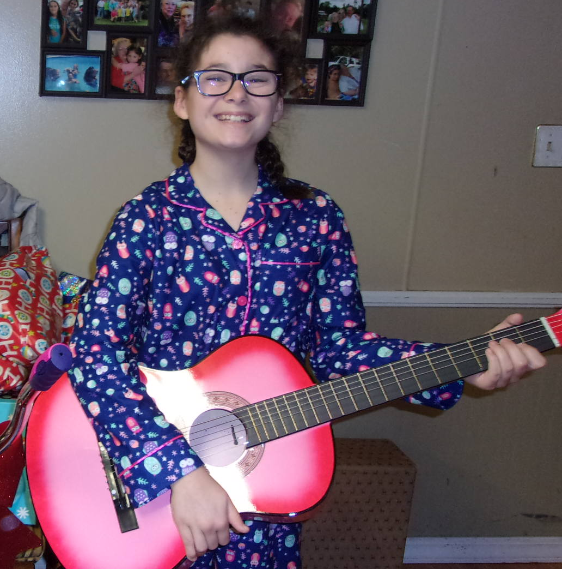
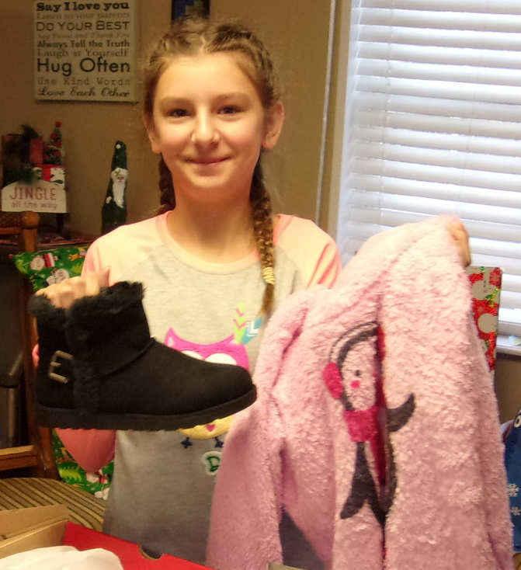
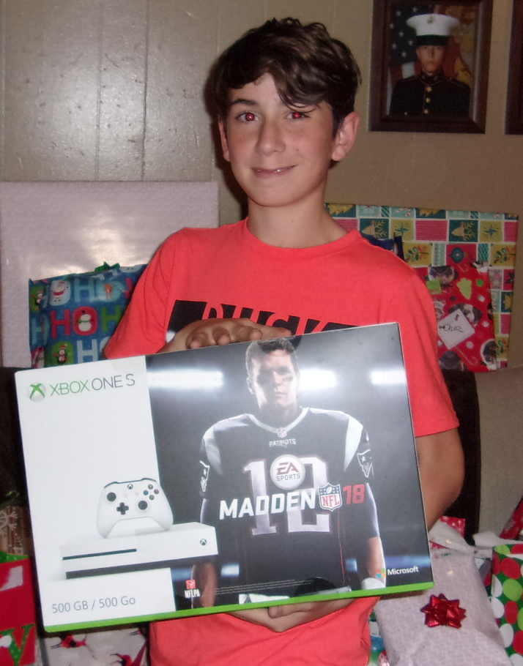

Jordin Lilly Mimi Chaz Eon Gabe
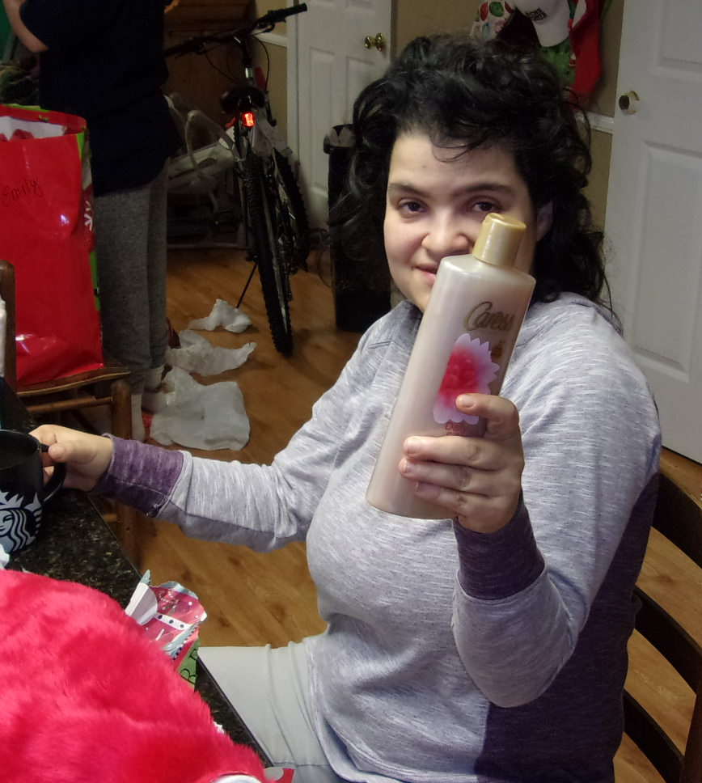
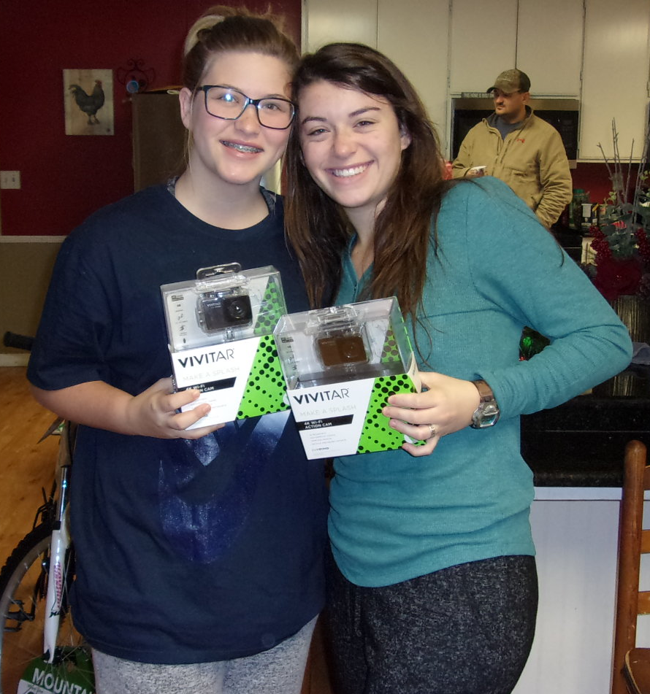
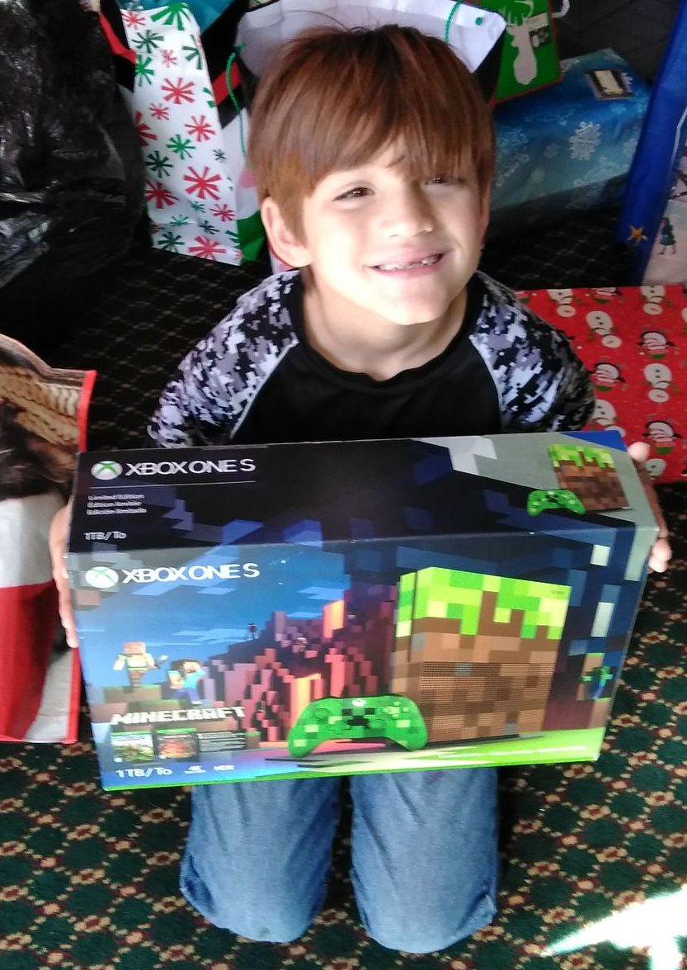
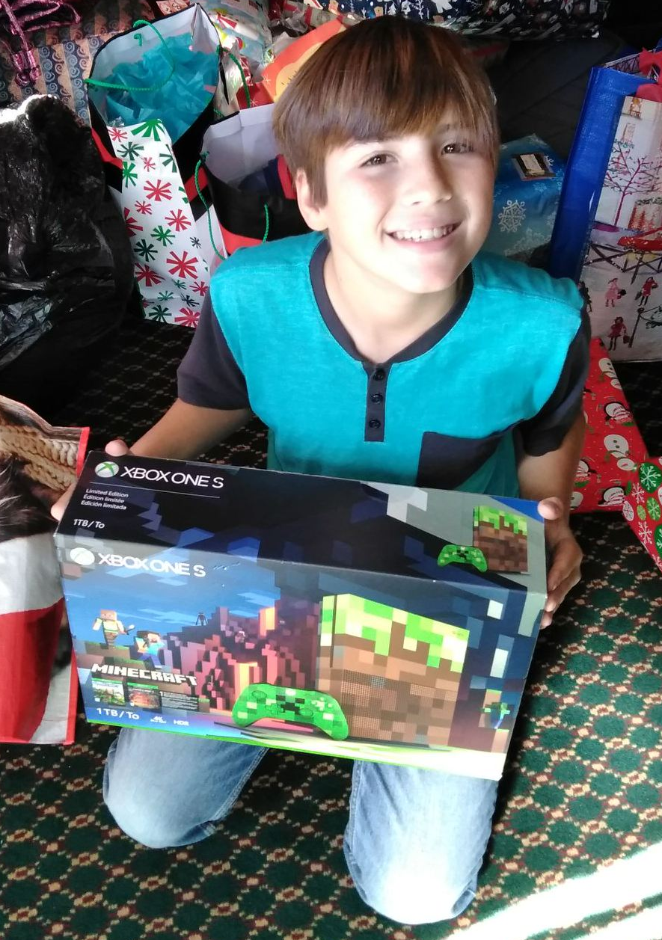
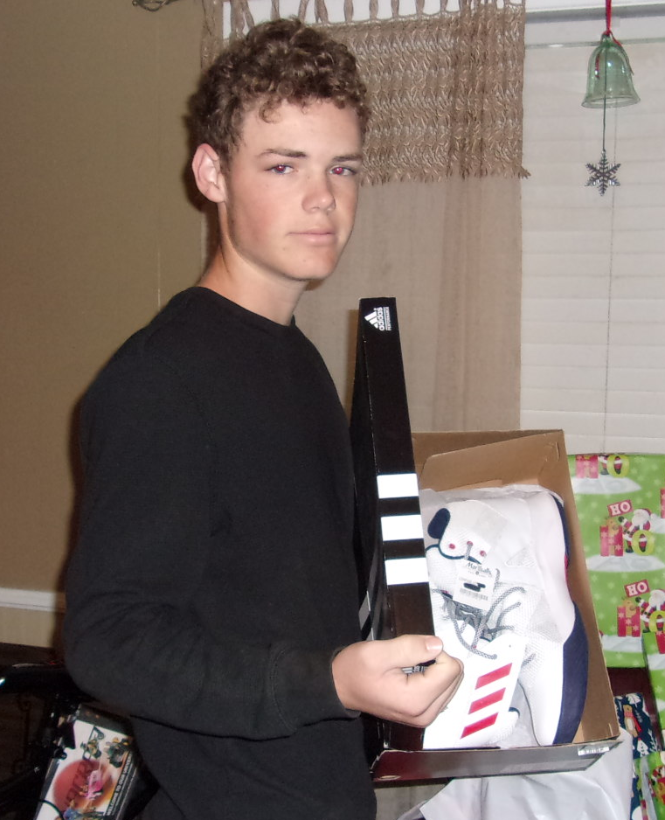
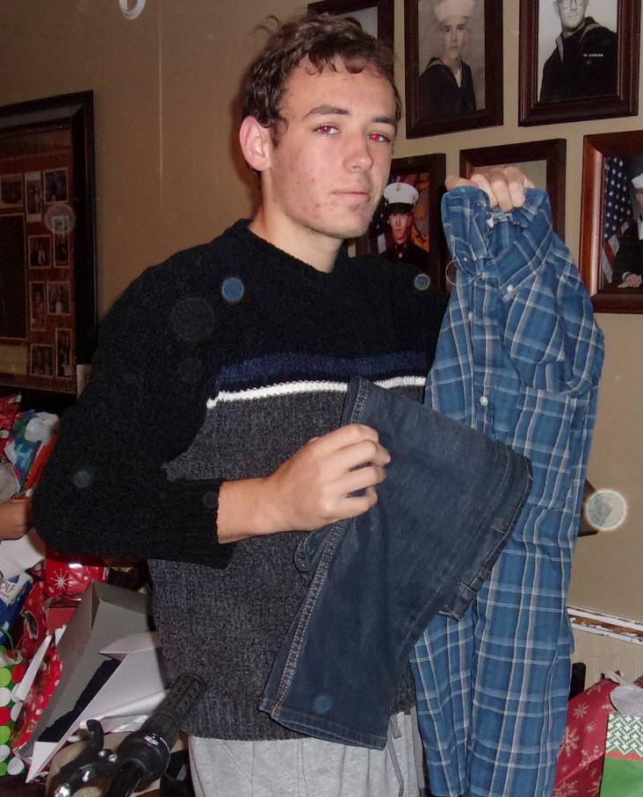

Elana Emily & Allie Aiden Noah Jacob Harold

